SOFTWARE REQUIREMENTS SPECIFICATION
Development of a Smart Digital Platform to Promote Eco & Cultural Tourism in Jharkhand

Submitted By
Monisha N – 24CSR186
Mythili S – 24CSR194
Narmadha P – 24CSR196
Nishalini R – 24CSR210

Department of Computer Science and Engineering
Kongu Engineering College
Perundurai, Erode – 638060, Tamil Nadu, India

Table of Contents
Table of Contents 2
List of Figures 4
1.0 Introduction 5
1.1 Purpose 5
1.2 Scope of Project 5
1.2.1 MVP Scope vs. Future Roadmap 5
1.3 Glossary 5
1.4 References 6
1.5 Overview of Document 6
2.0 Overall Description 8
2.1 System Environment 8
2.2 Functional Requirements Specification 8
2.2.1 Tourist Use Cases 8
Use Case: Register / Log In 9
Use Case: Search Tourist Destination 9
Use Case: Create Booking 9
Use Case: Make Payment 9
Use Case: Submit Feedback 9
Use Case: Request Personalized Itinerary 10
2.2.2 Local Service Provider Use Cases 10
Use Case: Register Tourism Service 10
2.2.3 Tourism Administrator Use Cases 10
Use Case: Update Tourist Information 11
Use Case: Register / Update Service Provider 11
Use Case: Verify Service Provider 11
Use Case: Add / Update Destination Information 12
Use Case: Process Tourist Feedback 12
Use Case: View Tourism Analytics 12
Use Case: Send Event Notification 12
Use Case: Remove Service Listing 12
2.2.4 Government Official Use Case 12
Use Case: View Tourism Analytics (Read-Only) 12
2.3 User Characteristics 12
2.4 Non-Functional Requirements 13
3.0 Requirements Specification 14
3.1 External Interface Requirements 14
3.2 Functional Requirements 14
3.2.1 Register / Log In 14
3.2.2 Search Destination 14
3.2.3 Create Booking 15
3.2.4 Process Payment 16
3.2.5 Communicate 16
3.2.6 Submit Feedback 17
3.2.7 Request Personalized Itinerary 17
3.2.8 Register / Update Service Provider 18
3.2.9 Verify Service Provider 18
3.2.10 Add Tourist Destination 19
3.2.11 Update Tourist Destination 19
3.2.12 Update Person 20
3.2.13 Process Tourist Feedback 20
3.2.14 Send Response 21
3.2.15 Send Event Notification 21
3.2.16 Remove Service Listing 22
3.2.17 Purchase Marketplace Item 22
3.2.18 View Tourism Analytics 23
3.3 Detailed Non-Functional Requirements 24
3.3.1 Logical Structure of the Data 24
3.3.2 Security 27

List of Figures
- Figure 1 – System Environment ...................................................... 4
- Figure 2 – Tourism Service Workflow ................................................ 6
- Figure 3 – Tourism Administrator Use Cases ...................................... 9
- Figure 4 – Logical Structure of the Smart Digital Tourism Platform Data (Revised) .... 18

1.0 Introduction

1.1 Purpose
The purpose of this Software Requirements Specification (SRS) document is to present a detailed description of the Smart Digital Platform to Promote Eco & Cultural Tourism in Jharkhand. It explains the objectives, features, interfaces, functional requirements, system constraints, and expected behavior of the proposed platform. This document serves as a reference for stakeholders, developers, testers, and the Government of Jharkhand during the design, development, testing, and maintenance of the system.
The platform aims to enhance tourism by providing tourists with reliable information, AI-powered itinerary planning, multilingual chatbot assistance, verified guide listings, secure online transactions, real-time location services, an integrated marketplace for local communities, and analytics for tourism authorities.

1.2 Scope of Project
The proposed software system is a Smart Digital Tourism Platform developed to promote eco-tourism and cultural tourism across Jharkhand. The platform provides a centralized digital solution that connects tourists, government authorities, local communities, guides, transport providers, homestays, and tribal artisans.
The system is designed to improve tourist experiences by providing authentic information about tourist destinations, transportation, accommodations, local events, eco-tourism activities, and cultural heritage sites.
More specifically, the platform allows tourists to register and log in, search tourist destinations, create and pay for bookings, receive AI-based personalized travel itineraries, communicate through a multilingual chatbot, book verified guides and homestays, purchase tribal handicrafts through an integrated marketplace, receive real-time navigation and transport information using geolocation, and provide feedback for AI-based sentiment analysis.
The platform also enables Tourism Administrators to manage destinations, verify local service providers, monitor tourism activities, and analyze visitor statistics through an analytics dashboard, and enables Government Officials to view read-only tourism analytics.

1.2.1 MVP Scope vs. Future Roadmap
To keep this specification honest about what is achievable within a hackathon prototype timeframe, features are split into two tiers. This distinction did not exist in the previous revision, where every feature was described as though it were equally ready to build; it is added here so evaluators can see exactly what will be demonstrated versus what is a stated direction for production.
- MVP (built and demoed): Registration/Login, Destination Search, Booking creation and payment, Feedback submission and review, Service Provider registration and verification (document-based, with a tamper-evident hash log rather than a full blockchain network), rule-based/content-based recommendation engine, basic chatbot, Admin and read-only Government Official dashboards.
- Future Roadmap (post-hackathon / production): Full blockchain-based verification network, AR/VR destination previews, full marketplace checkout and logistics, production-scale infrastructure (target concurrency beyond MVP levels).

1.3 Glossary
Term | Definition
Tourist | A registered or guest user who searches destinations, books tourism services, and explores Jharkhand tourism.
Tourism Administrator | Government-authorised staff member responsible for managing tourism information, service providers, and analytics.
Local Service Provider | Guide, homestay owner, transport operator, artisan, or cultural event organizer registered on the platform.
Government Official | A read-only stakeholder who monitors tourism growth, visitor trends, and platform performance via the analytics dashboard.
Booking | A record linking a Tourist, a Service Provider, and a Destination for a planned visit or service.
Payment | A recorded transaction that settles a Booking through the integrated payment gateway.
AI Recommendation Engine | Software module that generates personalized travel itineraries based on tourist preferences.
Verification Ledger | A tamper-evident audit record (hash-chained log) used to certify Local Service Providers; may be upgraded to a full blockchain network in production.
Marketplace | Digital storefront for selling tribal handicrafts and local products alongside bookable tourism services.
GIS | Geographic Information System used for location tracking, maps, and route navigation.
Multilingual Chatbot | AI assistant that communicates with tourists in multiple languages.
Analytics Dashboard | Dashboard used by Tourism Administrators and Government Officials to monitor tourism statistics and platform performance.
SRS | Software Requirements Specification — a document that completely describes the functions of a proposed system and the constraints under which it must operate.
Stakeholder | Government agencies, tourists, local communities, developers, and tourism service providers.

1.4 References
- IEEE Std 830-1998 – IEEE Recommended Practice for Software Requirements Specifications.
- Smart India Hackathon 2025 Problem Statement No. SIH25032.
- Government of Jharkhand Tourism Department.
- Google Maps Platform Documentation.
- FastAPI Documentation.
- React Documentation.
- PostgreSQL Documentation.

1.5 Overview of Document
Chapter 2 provides an overview of the Smart Digital Tourism Platform, including its users, operating environment, and major functionalities, expressed as use cases.
Chapter 3 presents the detailed functional requirements, software interfaces, database requirements, system features, and technical specifications required for implementing the platform.
Both chapters describe the same software system but are intended for different audiences. The Overall Description provides a high-level understanding for stakeholders, while the Requirements Specification presents detailed technical information for developers and testers.

2.0 Overall Description

2.1 System Environment
The Smart Digital Tourism Platform consists of four active actors and several external supporting systems.
- The Tourist accesses the platform through the Internet using a mobile application or web application.
- The Local Service Provider registers and manages tourism services such as guides, homestays, transport facilities, handicrafts, and eco-tourism activities.
- The Tourism Administrator manages destinations, service providers, tourism information, recommendations, and system operations.
- The Government Official monitors tourism growth and platform performance through a read-only analytics dashboard.
The platform interacts with external services including Google Maps / GIS Services, an AI Recommendation Engine, a Verification / Audit Ledger, a Payment Gateway, Notification Services (Email/SMS), and the Government Tourism Database.
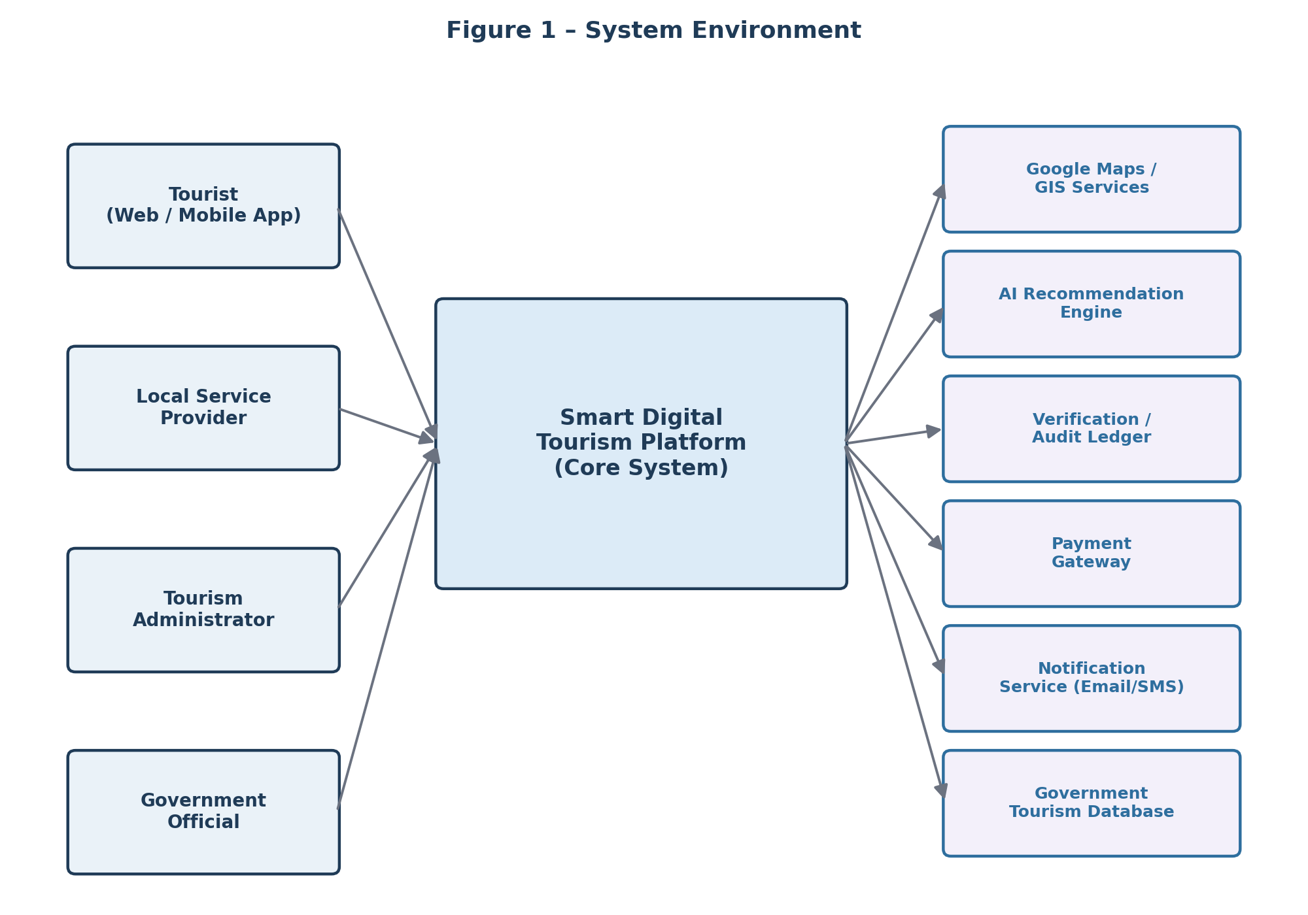
Figure 1 – System Environment

2.2 Functional Requirements Specification
This section outlines the use cases for each active actor. Two use cases that were missing from the previous revision — Register/Login and Create Booking — are added here because every workflow in this system, including the Booking entity at the centre of the database design (Figure 4), depends on them.

2.2.1 Tourist Use Cases

Use Case: Register / Log In
Brief Description: A new Tourist creates an account, or an existing Tourist authenticates, to access personalised features such as bookings, saved destinations, and feedback.
Initial Step-by-Step Description: 1. The Tourist selects Register or Log In. 2. For registration, the Tourist supplies name, email, phone number, and password; the system validates and creates the account. 3. For login, the Tourist supplies email and password; the system authenticates the credentials. 4. The system creates a session and directs the Tourist to the home screen.
Xref: Section 3.2.1, Register / Log In

Use Case: Search Tourist Destination
Brief Description: The Tourist searches for tourist destinations, eco-tourism locations, cultural heritage sites, tribal festivals, wildlife parks, or pilgrimage places, and views detailed information about a selected destination.
Initial Step-by-Step Description: Before this use case begins, the Tourist has already logged into the platform. 1. The Tourist chooses to search by destination name, district, category, activity, or keyword. 2. The system displays matching destinations. 3. The Tourist selects a destination. 4. The system presents destination details including description, images, maps, transportation, nearby attractions, accommodation, and guide information. 5. The Tourist chooses to book or save the destination.
Xref: Section 3.2.2, Search Destination

Use Case: Create Booking
Brief Description: The Tourist books a guide, homestay, or transport service for a selected destination.
Initial Step-by-Step Description: Before this use case begins, the Tourist has selected a Destination and an available Service Provider. 1. The Tourist selects Book Now. 2. The system displays available dates and provider options. 3. The Tourist confirms the visit date and service details. 4. The system creates a Booking record with status Pending. 5. The Tourist proceeds to Payment. 6. On successful payment, the system sets Booking status to Confirmed and notifies the Tourist and Service Provider.
Xref: Section 3.2.3, Create Booking

Use Case: Make Payment
Brief Description: The Tourist completes a secure online payment to confirm a Booking.
Initial Step-by-Step Description: 1. The Tourist selects a payment method. 2. The system redirects to the Payment Gateway. 3. The Tourist completes the transaction. 4. The gateway returns a success or failure status. 5. The system records the Payment and updates the Booking status accordingly.
Xref: Section 3.2.4, Process Payment

Use Case: Submit Feedback
Brief Description: The Tourist submits feedback and ratings after visiting a tourist destination or using tourism services.
Initial Step-by-Step Description: Before this use case can be initiated, the Tourist has completed a booked visit. 1. The Tourist selects Submit Feedback for a completed Booking. 2. The system displays the feedback form. 3. The Tourist provides a rating and comments. 4. The system stores the feedback against the Booking and Destination. 5. AI-based sentiment analysis evaluates the feedback. 6. The system generates a confirmation notification.
Xref: Section 3.2.6, Submit Feedback

Use Case: Request Personalized Itinerary
Brief Description: The Tourist requests an AI-generated itinerary on demand, based on stated interests such as eco-tourism, adventure tourism, pilgrimage tourism, tribal culture, wildlife, or heritage tourism.
Initial Step-by-Step Description: 1. The Tourist selects Plan My Trip. 2. The Tourist specifies interests, duration, and budget. 3. The AI Recommendation Engine generates a suggested itinerary. 4. The system displays the itinerary with linked destinations and providers. 5. The Tourist may save the itinerary or convert legs of it directly into Bookings.
Xref: Section 3.2.7, Request Personalized Itinerary

2.2.2 Local Service Provider Use Cases
The term Local Service Provider refers to registered guides, homestay owners, transport operators, tribal artisans, cultural event organizers, and eco-tourism service providers.

Use Case: Register Tourism Service
Brief Description: The Local Service Provider registers a new tourism service or updates an existing service on the Smart Digital Tourism Platform.
Initial Step-By-Step Description: Before this use case can be initiated, the Local Service Provider has already accessed the platform. 1. The Local Service Provider selects Register Service. 2. The system displays the registration form. 3. The Local Service Provider enters service details and uploads required documents. 4. The system performs validation and submits the record for administrator verification. 5. The system sends a registration acknowledgement notification.
Xref: Section 3.2.8, Register / Update Service Provider

2.2.3 Tourism Administrator Use Cases
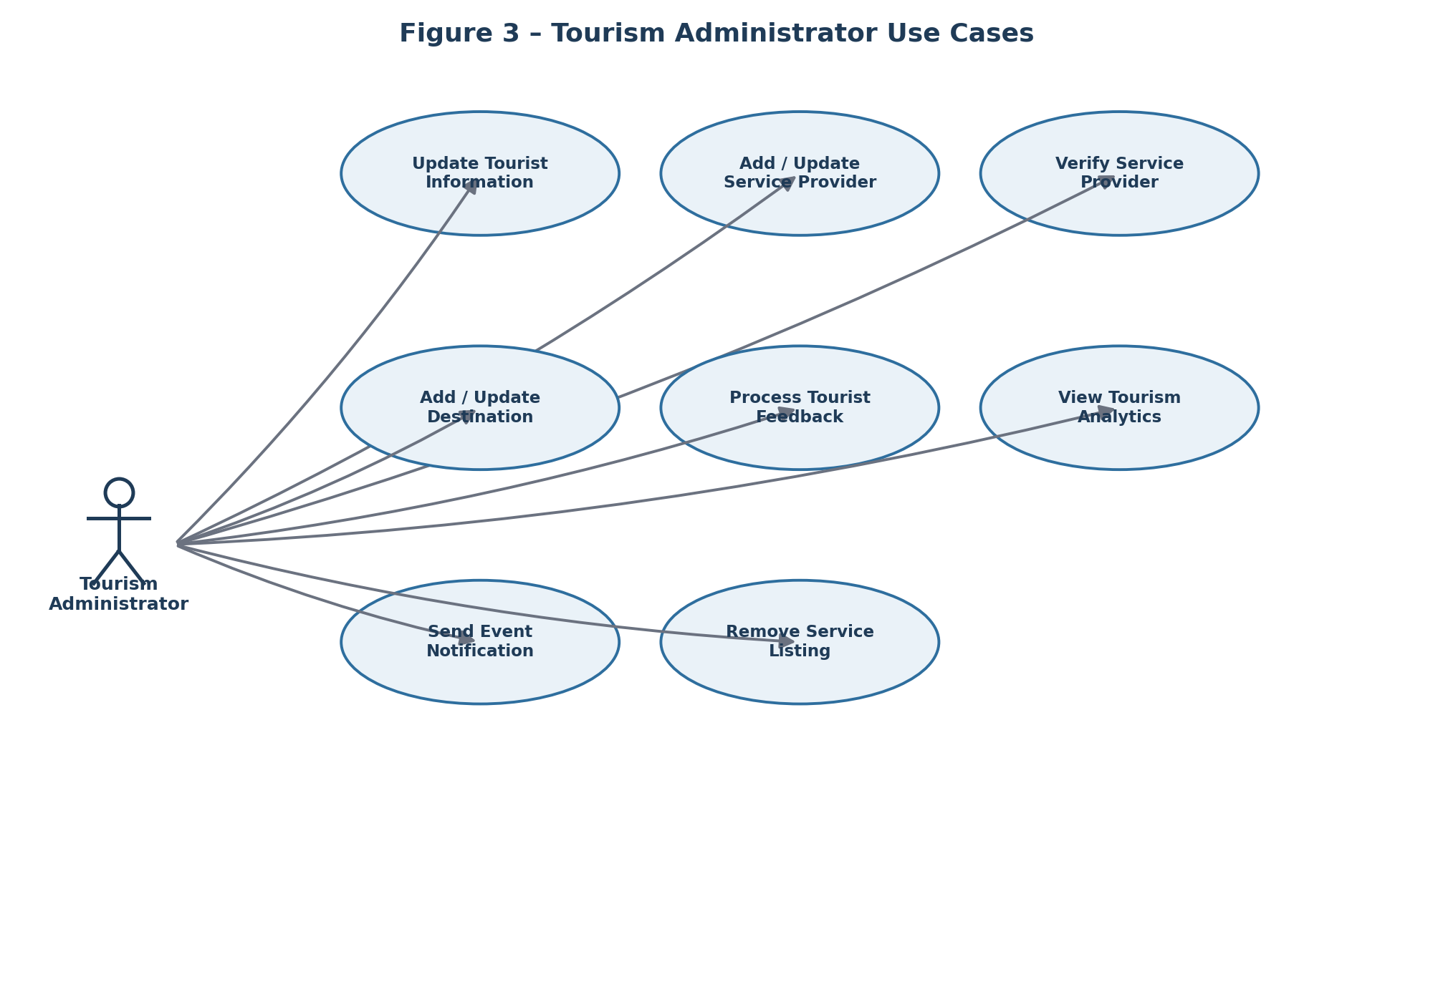
Figure 3 – Tourism Administrator Use Cases

Use Case: Update Tourist Information
Brief Description: The Tourism Administrator enters a new tourist record or updates information about an existing tourist, for support purposes.
Xref: Section 3.2.12, Update Person

Use Case: Register / Update Service Provider
Brief Description: The Tourism Administrator reviews a submitted Service Provider registration, edits its details if required, and forwards it for verification. This use case replaces the two overlapping use cases in the previous revision (‘Add Service Provider’ and ‘Add Verified Guide’), which described the same lifecycle stage twice under different names.
Xref: Section 3.2.8, Register / Update Service Provider

Use Case: Verify Service Provider
Brief Description: The Tourism Administrator verifies guides, homestays, transport providers, artisans, and eco-tourism service providers by validating submitted documents and recording the outcome in the Verification Ledger.
Initial Step-By-Step Description: 1. The Administrator selects Verify Service Provider. 2. The system displays pending verification requests. 3. The Administrator reviews submitted documents. 4. The Administrator approves or rejects the application. 5. On approval, a verification record is written to the ledger and the provider becomes visible on the platform.
Xref: Section 3.2.9, Verify Service Provider

Use Case: Add / Update Destination Information
Brief Description: The Tourism Administrator adds a new tourist destination or updates information about an existing one, including cultural sites, eco-tourism locations, pilgrimage places, and festivals.
Xref: Section 3.2.10 / 3.2.11, Add / Update Tourist Destination

Use Case: Process Tourist Feedback
Brief Description: The Tourism Administrator reviews tourist feedback and AI-generated sentiment analysis to identify service improvements.
Xref: Section 3.2.13, Process Tourist Feedback

Use Case: View Tourism Analytics
Brief Description: The Tourism Administrator monitors tourism activities, visitor statistics, booking trends, and platform performance.
Xref: Section 3.2.18, View Tourism Analytics

Use Case: Send Event Notification
Brief Description: The Tourism Administrator sends notifications regarding cultural festivals, tribal fairs, eco-tourism events, and local activities.
Xref: Section 3.2.15, Send Event Notification

Use Case: Remove Service Listing
Brief Description: The Tourism Administrator removes invalid, inactive, fraudulent, or policy-violating service listings.
Xref: Section 3.2.16, Remove Service Listing

2.2.4 Government Official Use Case

Use Case: View Tourism Analytics (Read-Only)
Brief Description: The Government Official views aggregated, read-only tourism analytics — visitor statistics, booking trends, popular destinations, and revenue trends — without administrative edit rights. This use case was entirely absent from the previous revision even though Government Official was listed as one of four system actors.
Initial Step-By-Step Description: 1. The Government Official logs in with a read-only role. 2. The system displays the analytics dashboard filtered to aggregate, non-personally-identifiable statistics. 3. The Official filters by district, category, or date range. 4. The system displays updated results.
Xref: Section 3.2.18, View Tourism Analytics

2.3 User Characteristics
The Tourist and Local Service Provider are expected to be familiar with the use of smartphones, web applications, and internet-based services. Tourists should be able to use GPS navigation, search destinations, interact with AI chatbots, and make online bookings and payments. Local Service Providers, including guides, artisans, homestay owners, transport operators, and event organizers, should be capable of using mobile devices to manage their profiles, update service information, receive bookings, and participate in the integrated tourism marketplace.
The Tourism Administrator is expected to be proficient in managing digital platforms and monitoring tourism-related activities through the administration dashboard, including verifying service providers, managing destination information, analysing tourist feedback, and overseeing platform operations. Government Officials are expected to use analytics dashboards and reporting tools to monitor tourism growth, visitor trends, and the overall performance of tourism initiatives across Jharkhand, without needing to manage day-to-day platform operations.

2.4 Non-Functional Requirements
The previous revision listed feature capabilities (AI itinerary generation, blockchain verification, AR/VR, GIS mapping, chatbot support) under Non-Functional Requirements. Those are functional capabilities and have been moved to Section 3.2 as functional requirements. This section retains only genuine quality attributes, with MVP-realistic targets rather than unqualified production-scale numbers.
- Performance: The platform shall respond to common requests (search, view details) within 3 seconds under nominal load during the pilot phase.
- Scalability: The architecture shall support horizontal scaling. MVP target: up to 2,000 concurrent users across pilot districts, with a documented scale-up path for statewide production deployment.
- Reliability / Availability: Target uptime of 99% during the pilot phase, monitored and reported; production targets to be revisited once real usage data is available.
- Security: See Section 3.3.2 for detailed security requirements (encryption, role-based access, session management, audit logging).
- Usability: The platform shall be accessible on both mobile and web, and shall support multiple regional languages in its user interface and chatbot.
- Maintainability: The system shall be built with modular services so that individual modules (booking, verification, analytics) can be updated independently.
- Compliance: The platform shall comply with applicable Government of India data protection guidelines for storage and processing of tourist personal data.

3.0 Requirements Specification

3.1 External Interface Requirements
The Smart Digital Tourism Platform shall interact with multiple external systems to provide comprehensive tourism services across Jharkhand. These external interfaces include the Government Tourism Database for accessing destination information, tourism policies, cultural event schedules, and tourism statistics; GIS and Mapping Services for real-time navigation, geolocation tracking, route planning, and interactive maps; and the Verification Ledger for validating local guides, homestays, transport operators, artisans, and eco-tourism service providers. The platform shall also integrate with a secure Payment Gateway to facilitate online bookings, ticket purchases, handicraft sales, and other tourism-related transactions.
In addition, the platform shall connect with Notification Services to deliver emails, SMS alerts, chatbot responses, booking confirmations, and personalized travel recommendations to users. All interactions between the platform and external systems shall be carried out through secure APIs and encrypted communication channels to ensure data integrity, privacy, and reliability.

3.2 Functional Requirements

3.2.1 Register / Log In
Use Case Name | Register / Log In
XRef | Section 2.2.1, Register / Log In
Trigger | The Tourist selects Register or Log In from the landing page.
Precondition | The Tourism Portal is available.
Basic Path | 1. The Tourist selects Register or Log In.  2. For registration: the Tourist enters name, email, phone number, and password.  3. The system validates the input (unique email, password strength) and creates the account.  4. For login: the Tourist enters email and password.  5. The system authenticates the credentials and creates a session.  6. The Tourist is directed to the home screen.
Alternative Paths | If the email already exists during registration, the system prompts the Tourist to log in instead. If login credentials are incorrect, the system displays an error and permits retry.
Postcondition | A valid Tourist session exists.
Exception Paths | The Tourist may abandon registration/login at any time. After five failed login attempts, the system temporarily locks the account and notifies the Tourist by email.
Other | Passwords are stored encrypted. Applies analogously to Local Service Provider and Administrator accounts, each with role-based access.

3.2.2 Search Destination
Use Case Name | Search Destination
XRef | Section 2.2.1, Search Tourist Destination
Trigger | The Tourist accesses the Tourism Platform.
Precondition | The Tourism Portal is available.
Basic Path | 1. The Tourist chooses how to search the platform: Destination Name, Category, Location, Cultural Attraction, Eco-Tourism Site, or Keyword.  2. If the search is by Destination Name, the system creates and presents a list of available destinations.  3. The Tourist selects a destination.  4. The system displays destination details, images, travel information, nearby attractions, accommodations, and reviews.  5. The Tourist may save the destination or proceed to booking.
Alternative Paths | In Step 1, if the Tourist selects Category, the system presents a list of categories, then all destinations in the selected category. If the Tourist selects Keyword, the system presents a search box and searches all destination records.
Postcondition | The selected destination information is displayed.
Exception Paths | The Tourist may abandon the search at any time.
Other | Categories are managed dynamically by Tourism Administrators.

3.2.3 Create Booking
Use Case Name | Create Booking
XRef | Section 2.2.1, Create Booking
Trigger | The Tourist selects Book Now on a Destination or Service Provider page.
Precondition | The Tourist is logged in. The selected Service Provider is verified and available for the desired date.
Basic Path | 1. The system displays available dates and provider options for the selected destination.  2. The Tourist selects a visit date and confirms service details (guide / homestay / transport).  3. The system creates a Booking record with status Pending and reserves the slot.  4. The Tourist proceeds to the Make Payment use case.  5. On successful payment, the system sets Booking status to Confirmed.  6. The system notifies the Tourist and the Service Provider.
Alternative Paths | If no dates are available, the system suggests alternative providers or dates. If the Tourist abandons before payment, the Booking is held as Pending for a limited time window and then automatically released.
Postcondition | A Booking record exists with an accurate status (Pending, Confirmed, or Cancelled).
Exception Paths | The Tourist may cancel a Pending or Confirmed booking (see Booking History / Cancel Booking, out of scope for this revision's detailed spec but implied by the Booking_Status field).
Other | This use case did not exist in the previous SRS revision, even though Booking is the central table in the database design (Figure 4).

3.2.4 Process Payment
Use Case Name | Process Payment
XRef | Section 2.2.1, Make Payment
Trigger | The Tourist confirms booking details and proceeds to pay.
Precondition | A Pending Booking exists.
Basic Path | 1. The Tourist selects a payment method (card, UPI, wallet).  2. The system redirects to the Payment Gateway with the booking amount.  3. The Tourist completes the transaction on the gateway.  4. The gateway returns a success or failure status via callback.  5. The system records a Payment entry linked to the Booking and updates the Booking status.
Alternative Paths | If payment fails, the system notifies the Tourist and keeps the Booking Pending, allowing retry.
Postcondition | A Payment record exists, linked to the corresponding Booking, with an accurate status.
Exception Paths | The Tourist may cancel before completing payment on the gateway.
Other | This use case did not exist in the previous revision, despite the Payment Gateway being named as an external interface (Section 3.1).

3.2.5 Communicate
Use Case Name | Communicate
XRef | Section 2.2.1, Contact Support
Trigger | The Tourist selects Contact Support.
Precondition | The Tourist is logged into the platform.
Basic Path | 1. The Tourist selects a communication option.  2. The system opens the chatbot interface.  3. The Tourist submits a query.  4. The AI chatbot processes the request and generates a response.  5. If required, the query is escalated to a Tourism Administrator.
Alternative Paths | If the chatbot cannot resolve the issue, a support ticket is generated and the Administrator is notified.
Postcondition | The query is answered or a support ticket is generated.
Exception Paths | The user may terminate the conversation at any time.
Other | The system supports multilingual communication.

3.2.6 Submit Feedback
Use Case Name | Submit Feedback
XRef | Section 2.2.1, Submit Feedback
Trigger | The Tourist selects Submit Feedback for a completed Booking.
Precondition | The Tourist has a Booking with status Completed (visit date has passed).
Basic Path | 1. The Tourist selects Submit Feedback.  2. The system displays the feedback form pre-linked to the relevant Booking and Destination.  3. The Tourist provides a rating (1–5) and comments.  4. The system stores the feedback, linked to Booking_ID, Tourist_ID, and Destination_ID.  5. AI-based sentiment analysis evaluates the feedback.  6. The system generates a confirmation notification.
Alternative Paths | None.
Postcondition | Feedback is stored and linked to the originating Booking.
Exception Paths | The Tourist may abandon the form at any time.
Other | Linking Feedback to Booking_ID (added in this revision) corrects a mismatch in the previous data model, where Feedback referenced only Destination, not the specific visit.

3.2.7 Request Personalized Itinerary
Use Case Name | Request Personalized Itinerary
XRef | Section 2.2.1, Request Personalized Itinerary
Trigger | The Tourist selects Plan My Trip.
Precondition | The Tourist is logged in and has a profile with stated or inferred preferences.
Basic Path | 1. The Tourist specifies interests (eco-tourism, adventure, pilgrimage, tribal culture, wildlife, heritage), duration, and budget.  2. The AI Recommendation Engine generates a candidate itinerary from available destinations, events, and verified providers.  3. The system displays the itinerary with linked destinations and providers.  4. The Tourist may adjust preferences and regenerate, save the itinerary, or convert individual legs into Bookings.
Alternative Paths | If insufficient data exists to personalize, the system falls back to popular/curated itineraries for the selected region.
Postcondition | An itinerary is generated and, optionally, saved or converted to bookings.
Exception Paths | The Tourist may abandon the request at any time.
Other | This use case did not exist in the previous revision as a tourist-initiated action; it previously appeared only as an administrator-pushed notification (‘Send Response’).

3.2.8 Register / Update Service Provider
Use Case Name | Register / Update Service Provider
XRef | Section 2.2.2 / 2.2.3, Register Tourism Service; Register / Update Service Provider
Trigger | The Local Service Provider registers a new service, or the Tourism Administrator edits an existing provider's record.
Precondition | The Local Service Provider or Administrator has access to the platform.
Basic Path | 1. The system presents a registration form (new) or the existing record (update).  2. The Provider or Administrator enters or edits Name, Business Type, Contact Information, Location, and Government Identification, and uploads supporting documents.  3. The system validates mandatory fields.  4. The record is created or updated with Verification_Status = Pending (new) or unchanged (update).  5. The system sends an acknowledgement notification.
Alternative Paths | If any mandatory field is empty, the system prompts for completion before submission.
Postcondition | A Service Provider record exists or is updated, ready for the Verify Service Provider use case.
Exception Paths | The operation may be abandoned at any time.
Other | This single use case replaces two overlapping use cases from the previous revision (‘Add Service Provider’ and ‘Add Verified Guide’), which described the same onboarding step twice without a clear boundary between them.

3.2.9 Verify Service Provider
Use Case Name | Verify Service Provider
XRef | Section 2.2.3, Verify Service Provider
Trigger | The Tourism Administrator selects a pending service provider application.
Precondition | The service provider has completed registration.
Basic Path | 1. The Administrator opens the Verify Service Provider module.  2. The system displays pending verification requests.  3. The Administrator selects a provider and reviews submitted documents.  4. The Administrator approves or rejects the application.  5. On approval, the system writes a record to the Verification Ledger and generates a digital certificate.  6. The provider becomes visible on the platform (Verification_Status = Verified).
Alternative Paths | If required documents are incomplete, the system marks the application Pending and requests additional information.
Postcondition | The service provider's verification status is updated.
Exception Paths | The Administrator may cancel the verification process at any time.
Other | Only verified service providers are available for tourist bookings. See Section 1.2.1 for the MVP-level scope of the Verification Ledger.

3.2.10 Add Tourist Destination
Use Case Name | Add Tourist Destination
XRef | Section 2.2.3, Add / Update Destination Information
Trigger | The Tourism Administrator selects Add Destination.
Precondition | The Administrator has accessed the Tourism Management Dashboard.
Basic Path | 1. The Administrator opens the Add Destination module.  2. The system displays a destination registration form.  3. The Administrator enters destination details, images, maps, and category.  4. The system validates the entered data.  5. The destination is added to the database.  6. The system displays a confirmation message.
Alternative Paths | If mandatory fields are missing, the system prompts the Administrator to complete them.
Postcondition | The new tourist destination is successfully added.
Exception Paths | The Administrator may cancel the operation at any time.
Other | Only authorized Administrators can add tourist destinations.

3.2.11 Update Tourist Destination
Use Case Name | Update Tourist Destination
XRef | Section 2.2.3, Add / Update Destination Information
Trigger | The Tourism Administrator selects an existing destination to update.
Precondition | The Administrator is logged into the dashboard; the destination already exists.
Basic Path | 1. The Administrator opens Manage Destinations.  2. The system displays the list of registered destinations.  3. The Administrator selects a destination.  4. The system displays the destination details in an editable form.  5. The Administrator updates the information and submits.  6. The system validates and saves the changes, and displays a confirmation message.
Alternative Paths | If a mandatory field is left empty, the system displays an error message. If an image upload fails, the system allows another attempt.
Postcondition | The destination information is successfully updated and immediately visible to tourists.
Exception Paths | If the destination no longer exists, the update is cancelled. The Administrator may cancel at any time before saving.
Other | All changes are recorded with the date and time of modification. (The previous revision's version of this use case contained a broken, duplicated final step referencing a non-existent ‘Editor’ role; that has been corrected here.)

3.2.12 Update Person
Use Case Name | Update Person
XRef | Section 2.2.3, Update Tourist Information
Trigger | The Administrator selects an existing tourist, guide, artisan, homestay owner, transport provider, or event organizer to update.
Precondition | The person already exists in the platform database.
Basic Path | 1. The Administrator selects a category of person.  2. The system presents a list of registered persons in that category.  3. The Administrator selects a person to update.  4. The system presents the existing information in editable form.  5. The Administrator updates the information and submits.  6. The system checks required fields and updates the database.
Alternative Paths | If a mandatory field is missing, the system requests correction before saving.
Postcondition | The person's information has been updated successfully.
Exception Paths | If the person does not exist, the use case is abandoned. The Administrator may abandon the operation at any time.
Other | Used only for updating existing records; new registrations use Register / Update Service Provider.

3.2.13 Process Tourist Feedback
Use Case Name | Process Tourist Feedback
XRef | Section 2.2.3, Process Tourist Feedback
Trigger | The Tourism Administrator selects View Feedback.
Precondition | Tourists have submitted feedback through the platform.
Basic Path | 1. The Administrator opens the feedback module.  2. The system displays tourist ratings, comments, and sentiment analysis results.  3. The Administrator reviews the feedback.  4. The Administrator records necessary follow-up actions.  5. The system updates the feedback record's status.
Alternative Paths | None.
Postcondition | Tourist feedback has been reviewed.
Exception Paths | The Administrator may exit the module at any time.
Other | Feedback is used to improve tourism services and provider ratings.

3.2.14 Send Response
Use Case Name | Send Response
XRef | Section 2.2.1, Communicate
Trigger | The Tourism Administrator selects a tourist inquiry that needs a human reply.
Precondition | A tourist inquiry or escalated chatbot ticket exists in the system.
Basic Path | 1. The Administrator opens the inquiry.  2. The system displays the inquiry details.  3. The Administrator enters and sends a response.  4. The communication history is updated.
Alternative Paths | None.
Postcondition | The response is successfully sent to the tourist.
Exception Paths | The Administrator may cancel before sending.
Other | Responses can be sent through email or in-app notification. (Previously mis-described as ‘extending Update Article,’ an unrelated use case left over from an earlier template; that reference has been removed.)

3.2.15 Send Event Notification
Use Case Name | Send Event Notification
XRef | Section 2.2.3, Send Event Notification
Trigger | The Tourism Administrator selects an event notification to send.
Precondition | Event details are available in the system.
Basic Path | 1. The Administrator selects an event.  2. The system retrieves event information.  3. The Administrator confirms the notification.  4. The system sends the notification to relevant users.  5. The notification history is updated.
Alternative Paths | If no target users are selected, the system sends the notification to all registered users interested in similar categories.
Postcondition | The event notification is delivered.
Exception Paths | The Administrator may cancel at any time.
Other | Notifications include festivals, fairs, tourism offers, and announcements.

3.2.16 Remove Service Listing
Use Case Name | Remove Service Listing
XRef | Section 2.2.3, Remove Service Listing
Trigger | The Tourism Administrator selects a service listing for removal.
Precondition | The selected service listing exists in the database.
Basic Path | 1. The Administrator opens the service listings.  2. The system displays all registered listings.  3. The Administrator selects a listing and confirms removal.  4. The system removes the listing from the active marketplace and records the action in audit logs.
Alternative Paths | None.
Postcondition | The selected service listing is removed.
Exception Paths | The Administrator may cancel the removal at any time.
Other | Only authorized Administrators can remove service listings.

3.2.17 Purchase Marketplace Item
Use Case Name | Purchase Marketplace Item
XRef | Section 1.2, Scope – Integrated Marketplace
Trigger | The Tourist selects a tribal handicraft or local product in the Marketplace.
Precondition | The Tourist is logged in; the product is in stock.
Basic Path | 1. The Tourist adds the product to a cart.  2. The Tourist proceeds to checkout.  3. The system creates an order linked to the Marketplace Product and Tourist.  4. The Tourist completes payment via the Process Payment use case.  5. The system confirms the order and notifies the Local Service Provider (artisan) to fulfil it.
Alternative Paths | If the product goes out of stock before checkout completes, the system notifies the Tourist and removes it from the cart.
Postcondition | An order exists linked to a Marketplace Product and a Payment.
Exception Paths | The Tourist may abandon the cart at any time.
Other | This use case, and the underlying Marketplace Product entity, did not exist anywhere in the previous revision even though the Marketplace was described in Scope (1.2) and defined in the Glossary (1.3). Full checkout/logistics remain a Future Roadmap item per Section 1.2.1; this specification covers the MVP-level flow.

3.2.18 View Tourism Analytics
Use Case Name | View Tourism Analytics
XRef | Section 2.2.3 / 2.2.4, View Tourism Analytics
Trigger | The Tourism Administrator or Government Official selects View Analytics.
Precondition | The user has logged into the analytics dashboard with the appropriate role.
Basic Path | 1. The system retrieves tourism data appropriate to the user's role (full detail for Administrators, aggregated/anonymised for Government Officials).  2. The dashboard displays visitor statistics, bookings, popular destinations, revenue trends, and tourist feedback summaries.  3. The user filters reports if required.  4. The system displays updated analytics.
Alternative Paths | None.
Postcondition | Analytics are displayed according to the user's role.
Exception Paths | The user may exit the dashboard at any time.
Other | Government Official access is read-only and excludes personally identifiable tourist data.

3.3 Detailed Non-Functional Requirements

3.3.1 Logical Structure of the Data
The logical structure of the data to be stored in the Smart Digital Tourism Platform database is given below. This revision corrects two mismatches from the previous version: Feedback now references the originating Booking (not only the Destination), and Payment, Marketplace Product, and Administrator entities have been added — these were referenced in the text (Scope, External Interfaces) but were missing from the data model entirely.
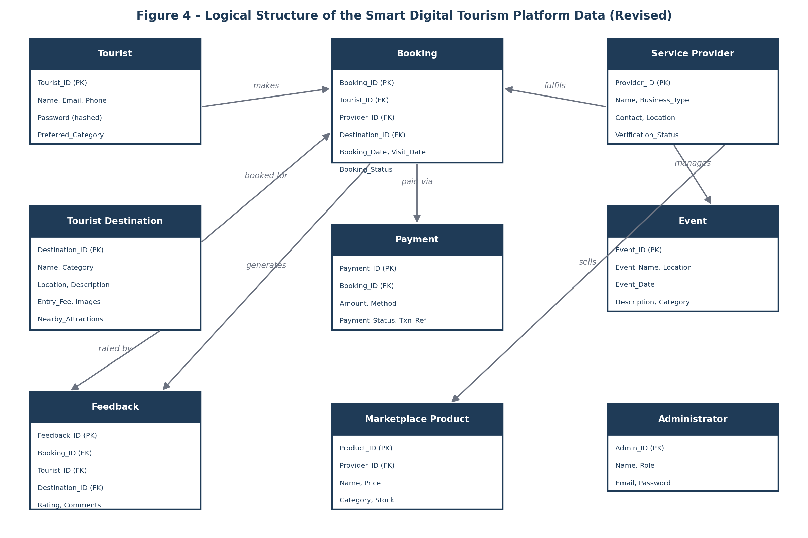
Figure 4 – Logical Structure of the Smart Digital Tourism Platform Data (Revised)

Tourist Data Entity
Data Item | Type | Description | Comment
Tourist_ID | Integer | Unique tourist identifier | Primary Key
Name | Text | Tourist's full name
Email_Address | Text | Email address | Unique
Phone_Number | Text | Contact number
Password | Text | Encrypted password
Preferred_Category | Text | Preferred tourism category | May be multiple

Service Provider Data Entity
Data Item | Type | Description | Comment
Provider_ID | Integer | Unique provider ID | Primary Key
Name | Text | Service provider name
Business_Type | Text | Guide, Homestay, Transport, Artisan, etc.
Contact_Number | Text | Contact details
Email_Address | Text | Email address
Location | Text | Service location
Verification_Status | Text | Pending, Verified, Rejected

Tourist Destination Data Entity
Data Item | Type | Description | Comment
Destination_ID | Integer | Unique destination ID | Primary Key
Destination_Name | Text | Name of tourist destination
Category | Text | Eco, Cultural, Heritage, Adventure, Religious
Location | Text | District / City
Description | Text | Destination details
Entry_Fee | Decimal | Entry fee | Optional
Images | Text | Image path or URL | May be several
Nearby_Attractions | Text | Nearby places

Booking Data Entity
Data Item | Type | Description | Comment
Booking_ID | Integer | Unique booking ID | Primary Key
Tourist_ID | Integer | Tourist who made the booking | Foreign Key
Provider_ID | Integer | Assigned service provider | Foreign Key
Destination_ID | Integer | Booked destination | Foreign Key
Booking_Date | Date | Date the booking was made
Visit_Date | Date | Planned visit date
Booking_Status | Text | Pending, Confirmed, Cancelled, Completed

Payment Data Entity (new in this revision)
Data Item | Type | Description | Comment
Payment_ID | Integer | Unique payment ID | Primary Key
Booking_ID | Integer | Booking being paid for | Foreign Key
Amount | Decimal | Transaction amount
Method | Text | Card, UPI, Wallet, etc.
Payment_Status | Text | Success, Failed, Refunded
Transaction_Reference | Text | Gateway transaction reference

Feedback Data Entity (Booking_ID added in this revision)
Data Item | Type | Description | Comment
Feedback_ID | Integer | Unique feedback ID | Primary Key
Booking_ID | Integer | Visit the feedback relates to | Foreign Key – corrects previous mismatch
Tourist_ID | Integer | Tourist who submitted feedback | Foreign Key
Destination_ID | Integer | Destination reviewed | Foreign Key
Rating | Integer | Rating (1–5)
Comments | Text | Tourist feedback
Feedback_Date | Date | Submission date

Event Data Entity
Data Item | Type | Description | Comment
Event_ID | Integer | Unique event ID | Primary Key
Event_Name | Text | Festival or tourism event
Location | Text | Event location
Event_Date | Date | Date of event
Description | Text | Event details
Category | Text | Cultural, Religious, Adventure, etc.

Marketplace Product Data Entity (new in this revision)
Data Item | Type | Description | Comment
Product_ID | Integer | Unique product ID | Primary Key
Provider_ID | Integer | Selling artisan / provider | Foreign Key
Name | Text | Product name
Price | Decimal | Unit price
Category | Text | Handicraft, Textile, Food, etc.
Stock | Integer | Units available

Administrator Data Entity (new in this revision)
Data Item | Type | Description | Comment
Admin_ID | Integer | Unique administrator ID | Primary Key
Name | Text | Administrator's name
Role | Text | Tourism Administrator or Government Official | Governs read/write access
Email_Address | Text | Email address | Unique
Password | Text | Encrypted password

3.3.2 Security
The Smart Digital Tourism Platform shall implement appropriate security mechanisms to protect user information and system data.
- Only registered users shall be allowed to access personalized services such as bookings, saved destinations, and feedback submission.
- Tourism Administrators shall have role-based access to manage destinations, service providers, events, and tourist information; Government Officials shall have read-only access to aggregated analytics only.
- User passwords shall be stored in encrypted form.
- All communication between the client and server shall use secure communication protocols (TLS).
- The system shall validate all user inputs to prevent unauthorized access and malicious attacks.
- Only authorized Administrators shall be permitted to add, update, or remove destinations, service providers, and tourism-related information.
- Regular database backups shall be maintained to prevent data loss.
- The system shall maintain activity logs for important administrative operations, including provider verification and listing removal.
- Session management shall automatically log out inactive users after a specified period.
- Access to the database shall be restricted to authorized system components and administrators only.
- Payment data shall not be stored directly on platform servers; the Payment entity stores only a gateway transaction reference, consistent with standard PCI-DSS practice.

